Software Development for Mobile Devices

# Submission for Assignment A2.1P

## Task 1. Separation of concerns

### Separation of concerns

Separation of concerns is a design principle in which the program is divided into distinct sections (Separation of concerns 2018). The benefit of separation of concerns is to reuse and maintain the program efficiently. In other words, the program is able to extend and update without causing any major impacts to current code.

It separates into presentation logic layer, business logic layer and data logic layer. The presentation logic layer is in charge of display the view to user. Business logic layer, on the other hand, uses to handle the business requirements of the application. Meanwhile, data logic layer supports store and retrieve data.

### How to use it in Android development

In android development, separation of concerns can be implemented as Model View Controller (MVC). The Model is the data logic layer, view is the presentation logic layer and controller is the business logic layer.

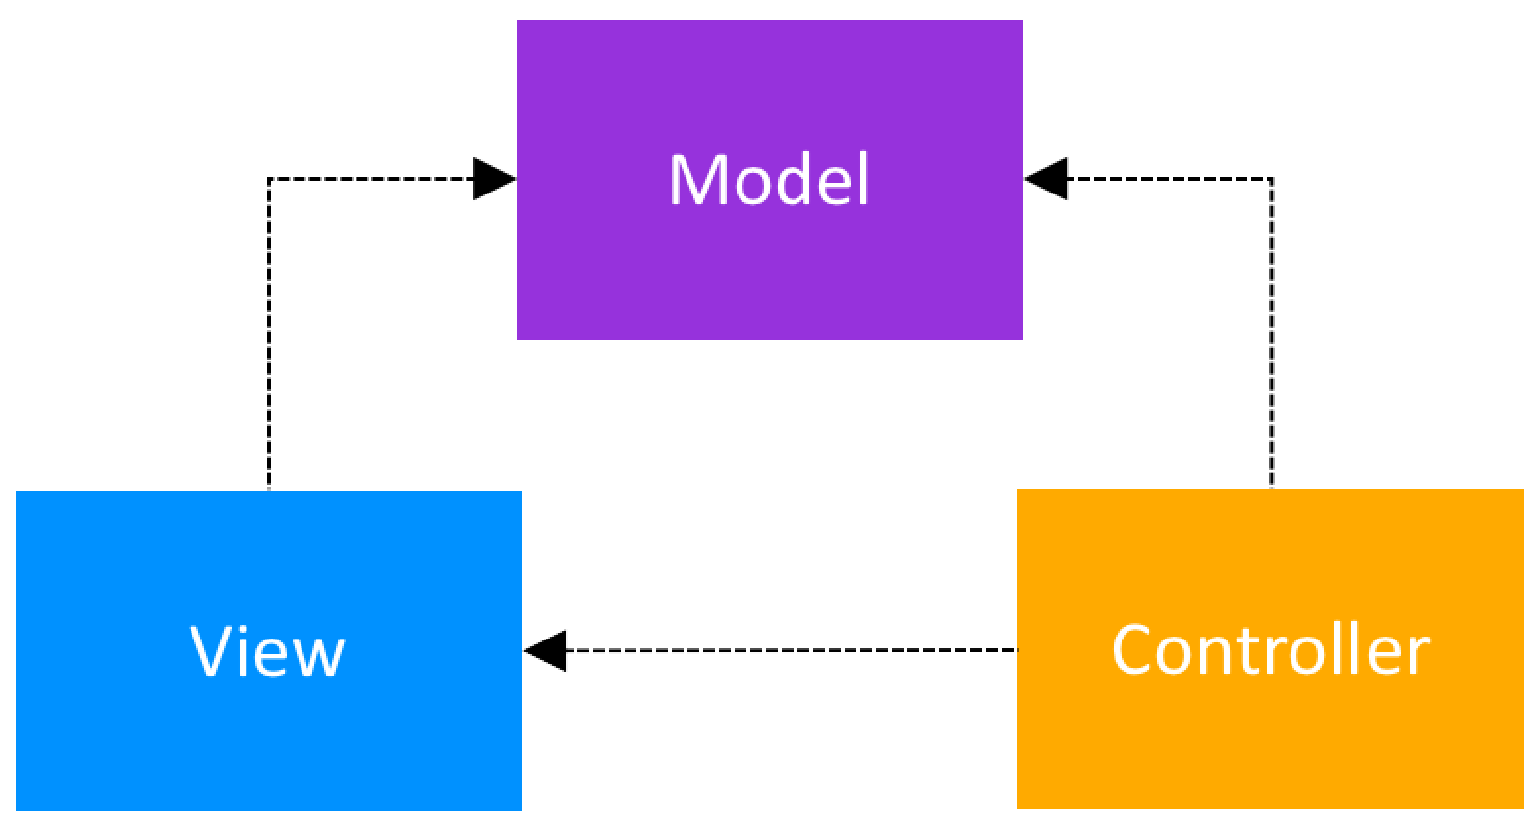

Figure 1: MVC model

This image is from (Muntenescu 2018)

**Model**

The model uses to manage how data is stored and used in the program.

**View**

View uses to display UI and allows users to interact with these UI components. In Android, View is the layout.

**Controller**

Controller stands in the middle of view and model. When users change data by interacting with the GUI, the controller will update the model automatically. In Android, Controller is the Activities and Fragments that manipulate how the view is displayed and update the data for the model.



Figure 2: MVC for Android project

# References

Muntenescu, F 2018, *Android Architecture Patterns Part 1: Model-View-Controller*, viewed 16 August 2018, <https://medium.com/upday-devs/android-architecture-patterns-part-1-model-view-controller-3baecef5f2b6>.

*Separation of concerns*, viewed 15 August 2018, <https://en.wikipedia.org/wiki/Separation_of_concerns>.